Dock Shelters | 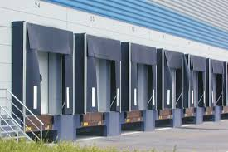
Make |  | NIHVA | Customer Requirement
Overall Width in MM |  | 2030
Shelter Type |  | Retractable / Inflatable
Size (W X H) in MM |  | 3000 x 3400

